Pathways to Policy:
A toolkit for grassroots involvement
in mental health policy

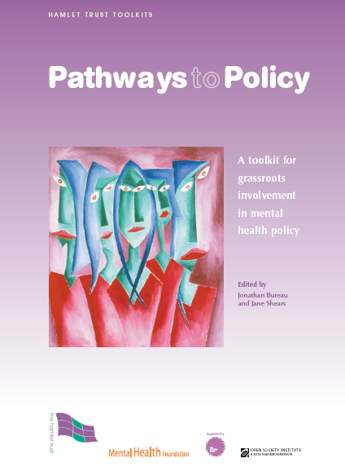

This new toolkit enables NGOs and user groups to promote the voice of service users in the development of mental health policy.

Drawing on the experiences of a 5-year programme, the toolkit provides a framework for establishing a mental health policy “forum” to enable people experiencing mental distress to have a genuine voice in policy-making. It provides a step-by-step guide to user groups to working in partnership with other stakeholders to prioritise local mental health issues, develop action plans and raise awareness.

The Pathways to Policy programme, originally developed in 2002 by the UK organisation Hamlet Trust, has seen the establishment of forums in a wide range of countries and contexts. Using socially inclusive approaches to policy-making, this toolkit draws on the experiences of those involved in the programme, and includes:

- Accessible, interactive study of concepts of policymaking, including both traditional and more inclusive/progressive methods.
- Workshop outlines, including exercises, to improve skills and confidence among service users and other stakeholders. (Materials are also provided on an accompanying CD Rom.)
- Training tools needed to develop a policy forum into a sustainable, influential body.
- Means of capturing and communicating outputs and outcomes.
- Advice and ideas on working with the media.
- How to evaluate the work of the forums using action learning methodology.
- Case studies and learning from successful mental health policy forums around the world.

“Such a framework for action can respond to the needs and aspirations of people with experience of mental distress by placing them at the centre of the process. I commend this toolkit to anyone who wishes to drive forward user empowerment.”
Andrew McCulloch, Chief Executive, Mental Health Foundation

The toolkit is free and available to download from www.hamlet-trust.org.uk

For hard copies and further information please contact Jonathan Bureau at the Hamlet Trust at office@hamlet-trust.org.uk

Produced by Hamlet Trust and Mental Health Foundation, with support from the Big Lottery Fund and Open Society Mental Health Initiative.

